Academy Use ONLY: ACCEPT: _____________ REJECTED: _____________ Score: _________

Bedford County
Governor’s Health Sciences Academy Application
Completed Application packets must include the following:
Please use black or blue ink
____ Completed Application (Submitted to BSTC)
____ Three Teacher Recommendations (one must be science)
Given to : _________________________
_________________________
_________________________
____ Counselor Report
Name of Counselor:
________________________

Application for Admission
Name:___________________________________ Student #____________________________
Home Phone:________________________________________Date of Birth:_______________
Student Phone (cell):_______________________ Student email:________________________
Address:_______________________________________________________________________
Base School:_____________________________________Current Grade:__________________
Counselor:_______________________________
Indicate which career Pathway you are applying for:

Answer the Questions below:
- Describe your future career goals and how you feel the Governor’s Health Sciences Academy can help you meet them.

- Why do you want to be accepted as a student in the Governor’s Health Sciences Academy?

- List any extracurricular activities, projects, programs, or community service activities you have participated in and the associated organizations.
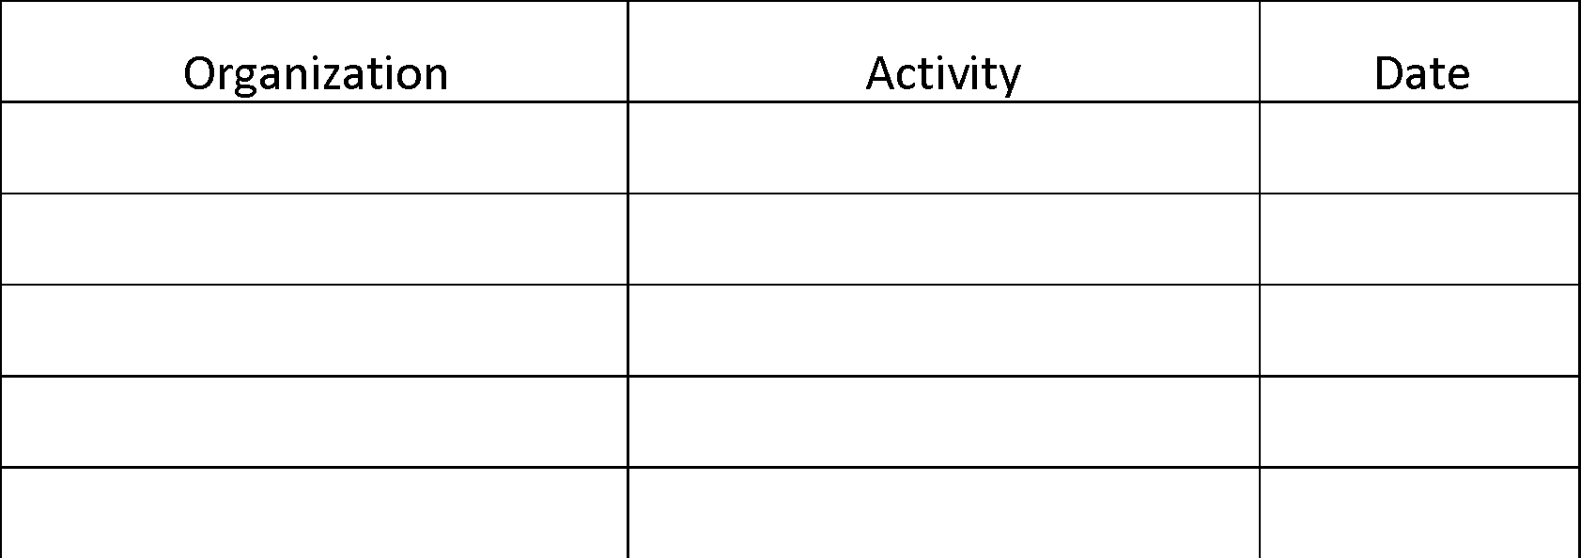

- Please feel free to provide any additional information you would like considered when reviewing your application.

To the best of my knowledge, the information on this application is accurate and represents my person point of view.
Student Signature:_________________________________________Date:_________________
Bedford County Public Schools does not discriminate on the basis of race, color, national origin, sex, or disability in its programs, activities, or employment practices as required by Title VI, Title IX, and Section 504.

